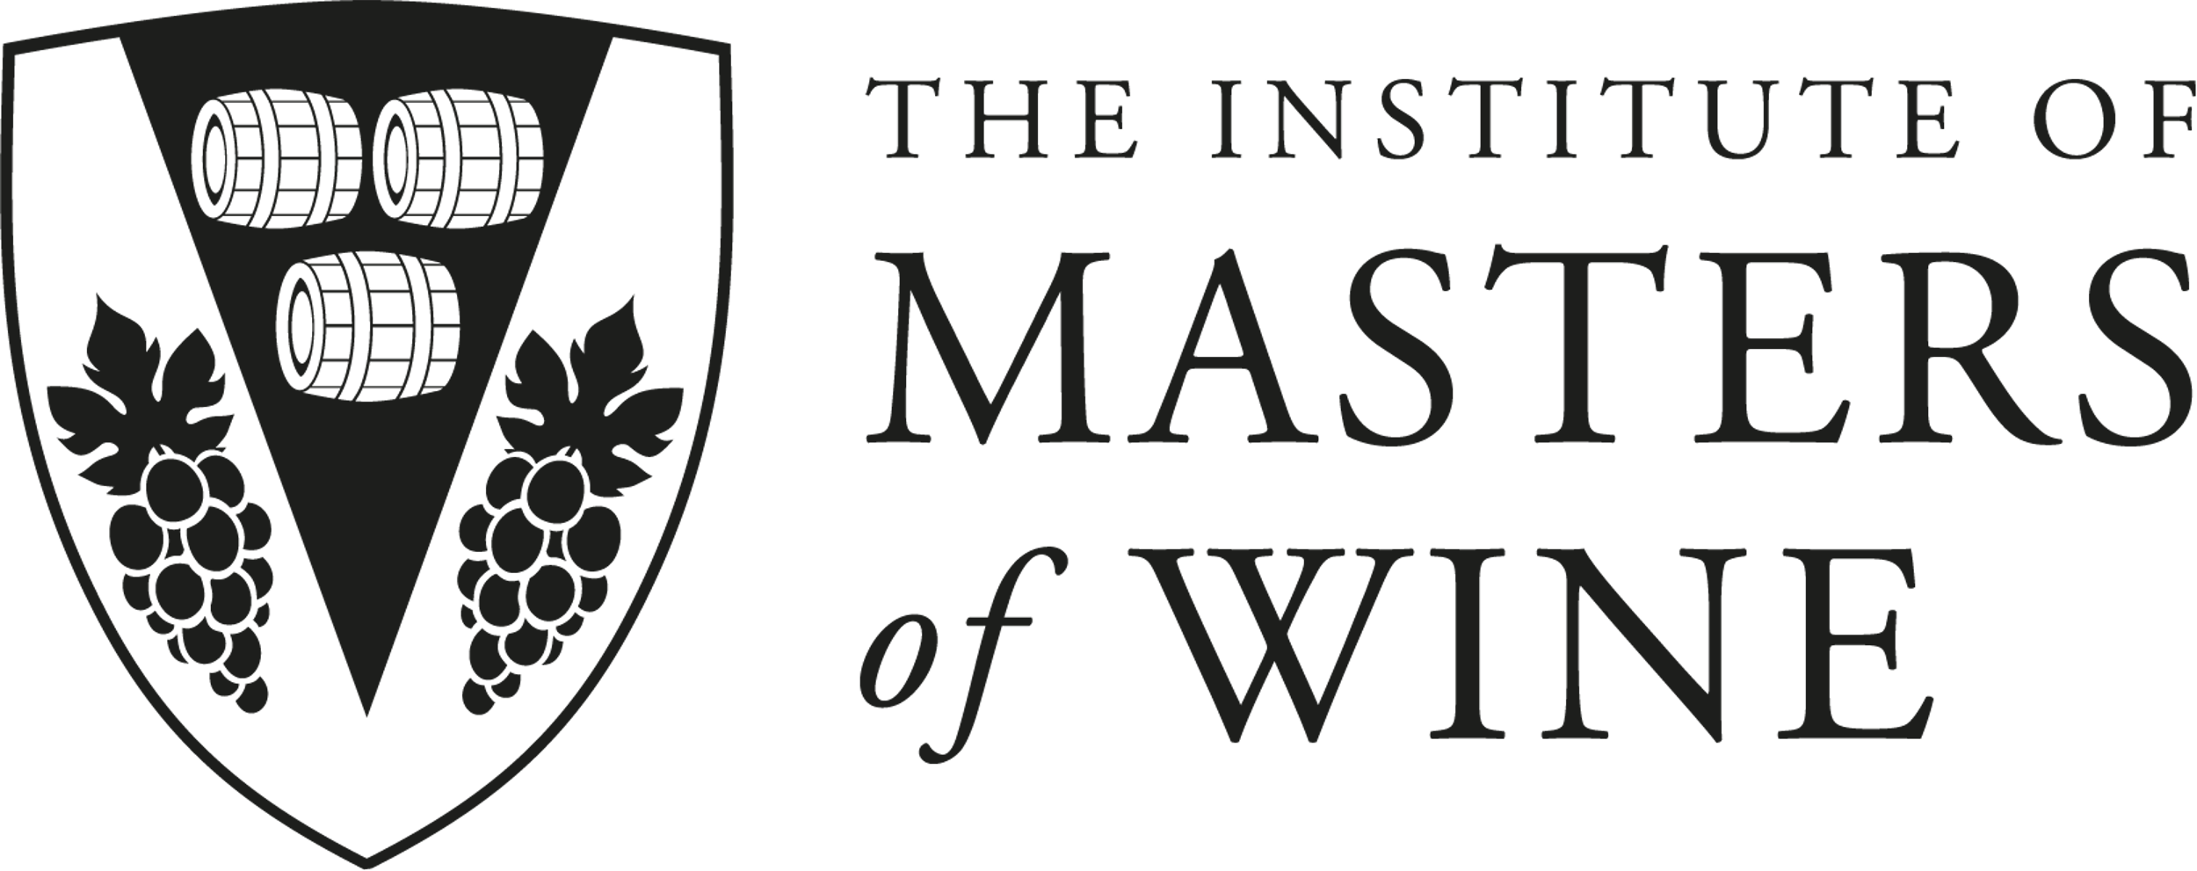
S1 PAMS submission form
DEADLINE 1
2025 -26 academic year
Candidate number | Click or tap here to enter text.
Is English your native language | Click or tap here to enter text.

AI Use Statement
- I declare that no part of this submission has been generated by AI software. These are my own words. Note. Using software for translation, English grammar and spell checking is consistent with Statement A. | ☐
- I declare that parts of this submission has contributions from AI software and that it aligns with acceptable use as specified as part of the assignment brief/ guidance and is consistent with good academic practice. The content can still be considered as my own words. | ☐

Please save your file as your CANDIDATE#_PAMS_ DEADLINE#
(for example – 12345_PAMS_1)
Upload it to the student area of the website here.
Please ensure that your name is not included in either the assignment or the file name.
Welcome to the Assignment Marking Scheme
The purpose of these assignments is to help you practice your approach to writing practical answers. While these exercises do not necessarily involve tasting specific wines, it is important to keep in mind that dry tasting notes can be extremely useful in helping you to develop an effective structure for your answers in order to communicate your analysis of the wine(s) in an effective way. Dry tasting notes can also be helpful in thinking through how you can more efficiently use your tasting observations as support for your argument.
Please note that all wines cited in these exercises are based on real-life examples. It is highly recommended that you think carefully about the kind of flavour/aroma characters you would expect these wines to show, and to consider relevant structural, textural and winemaking elements when creating your arguments. If you are not familiar enough with the wines in these exercises to allow you write answers in this way, this suggests that you need to make the effort to taste similar wines in real life.
For the sake of these dry note exercises, the prices cited should be considered to be strongly linked with the quality of the wines. This is not always the case in real life! However, in this instance, an entry-level price is indicative of the fact that the wine would show typical entry-level quality, while a wine at a mid-premium price would be expected to show characteristics associated with a higher quality level.
These questions are designed to help you get comfortable with a range of questions that you are likely to encounter across the three papers. These exercises are not graded, rather students are provided with feedback on their responses.

Feedback
Your completed assignment will be sent to a marker who will include their comments within the body of your answer and provide overall comments at the end of the document. It is important that you share the feedback with your mentor. Please note that your mentor is not responsible for re-marking the assignment. It should be used as a coaching and learning document to help you with your practical exam. After you have discussed your feedback with your mentor, if you have any questions or issues with the feedback, please email the IMW office.

How to start
To begin, for each wine, make observations (a tasting grid/cross/tasting notes) of what the wine might look, smell and taste like. Use your tasting grid/cross/notes (along with the given information) as evidence to support the argument that you are making when answering the question.
Use the boxes provided to write both your tasting grid/cross/notes and then your answers. Your answers should be timed and take no longer than 12-15 minutes per wine for parts a) to c) and allow a further 8 minutes per wine for the supplementary question.
Wine 1 Tasting Grid / Cross / Notes
Cabernet Sauvignon, Rutherford, Napa, 2017, UK RRP £91, 14.2% abv.
Aged for 18 months in French oak.
Click or tap here to enter text.

Wine 2 Tasting Grid / Cross / Notes
Margaux Cru Bourgeois Exceptionnel, Bordeaux, 2022, UK RRP £30, 13% abv.
80% Cabernet Sauvignon, 20% Merlot.
Click or tap here to enter text.

Wine 3 Tasting Grid / Cross / Notes
Cabernet Sauvignon, Coonawarra, 2020, UK RRP £15, 14% abv.
Matured for 10-12 months in new and old oak.
Click or tap here to enter text.

Questions to answer:
All three wines are made from the same predominant grape variety.

With reference to all three wines:
- Identify the grape variety. (12 marks)

For each wine:
- Identify the origin as closely as possible. (3x6 marks)
- Discuss quality with reference to maturity. (3x15 marks)
Enter your answers into the boxes provided below

With reference to all three wines:
- Identify the grape variety.
Click or tap here to enter text.
Wine 1
b) Identify the origin as closely as possible.
Click or tap here to enter text.

c) Discuss quality with reference to maturity.
Click or tap here to enter text.

Wine 2
b) Identify the origin as closely as possible.
Click or tap here to enter text.
c) Discuss quality with reference to maturity.
Click or tap here to enter text.
Wine 3
b) Identify the origin as closely as possible.
Click or tap here to enter text.
c) Discuss quality with reference to maturity.
Click or tap here to enter text.

For MW markers only

Comment on candidate’s use of evidence from the glass, if they answered the question, logic of the argument and length of the answer.

Comments for:
a) Identify the grape variety.
Click or tap here to enter text.

Comments for:
b) Identify the origin as closely as possible.
Click or tap here to enter text.

Comments for:
c) Discuss quality with reference to maturity.
Click or tap here to enter text.

Comments for:
Supplementary question:
Click or tap here to enter text.

